1st window menu:

chose the difficulty level from the selection area between Easy, Medium or Hard and select play

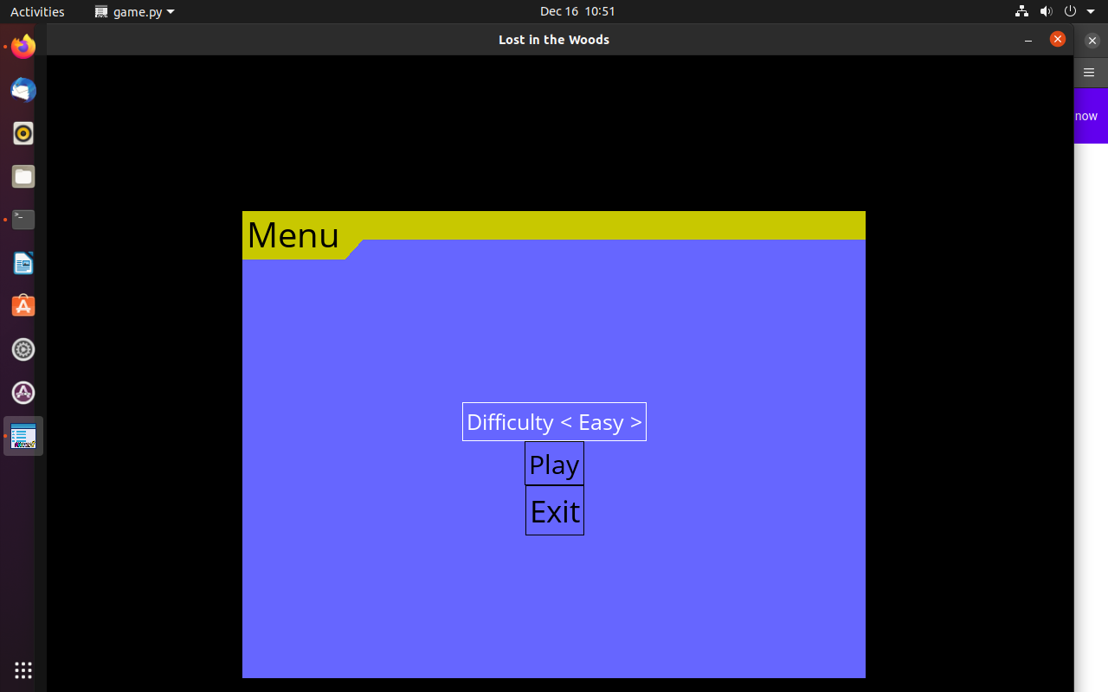

2nd window menu :

In this window menu chose row column and players from the selection menu and select the start button to play the game. Select Back to Menu button to go to the first window menu to chose difficulty level again. Select the Scores to see the previous scores.

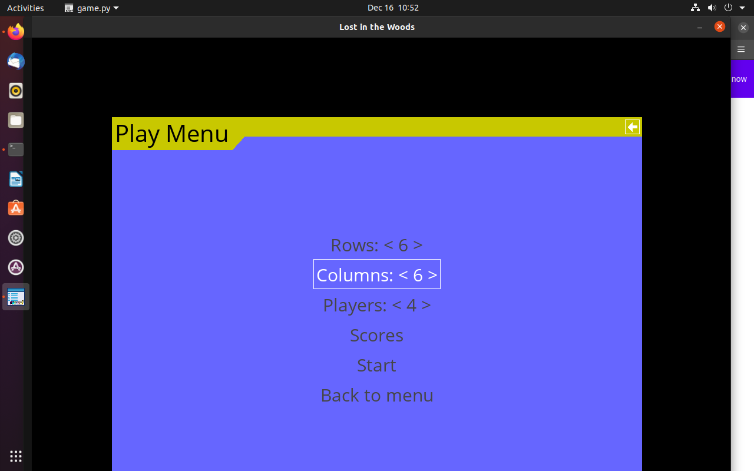

3rd window menu:

play the game and enjoy.

